Train the Trainer Course, Day 1

Different levels of contributing factors to radicalisation
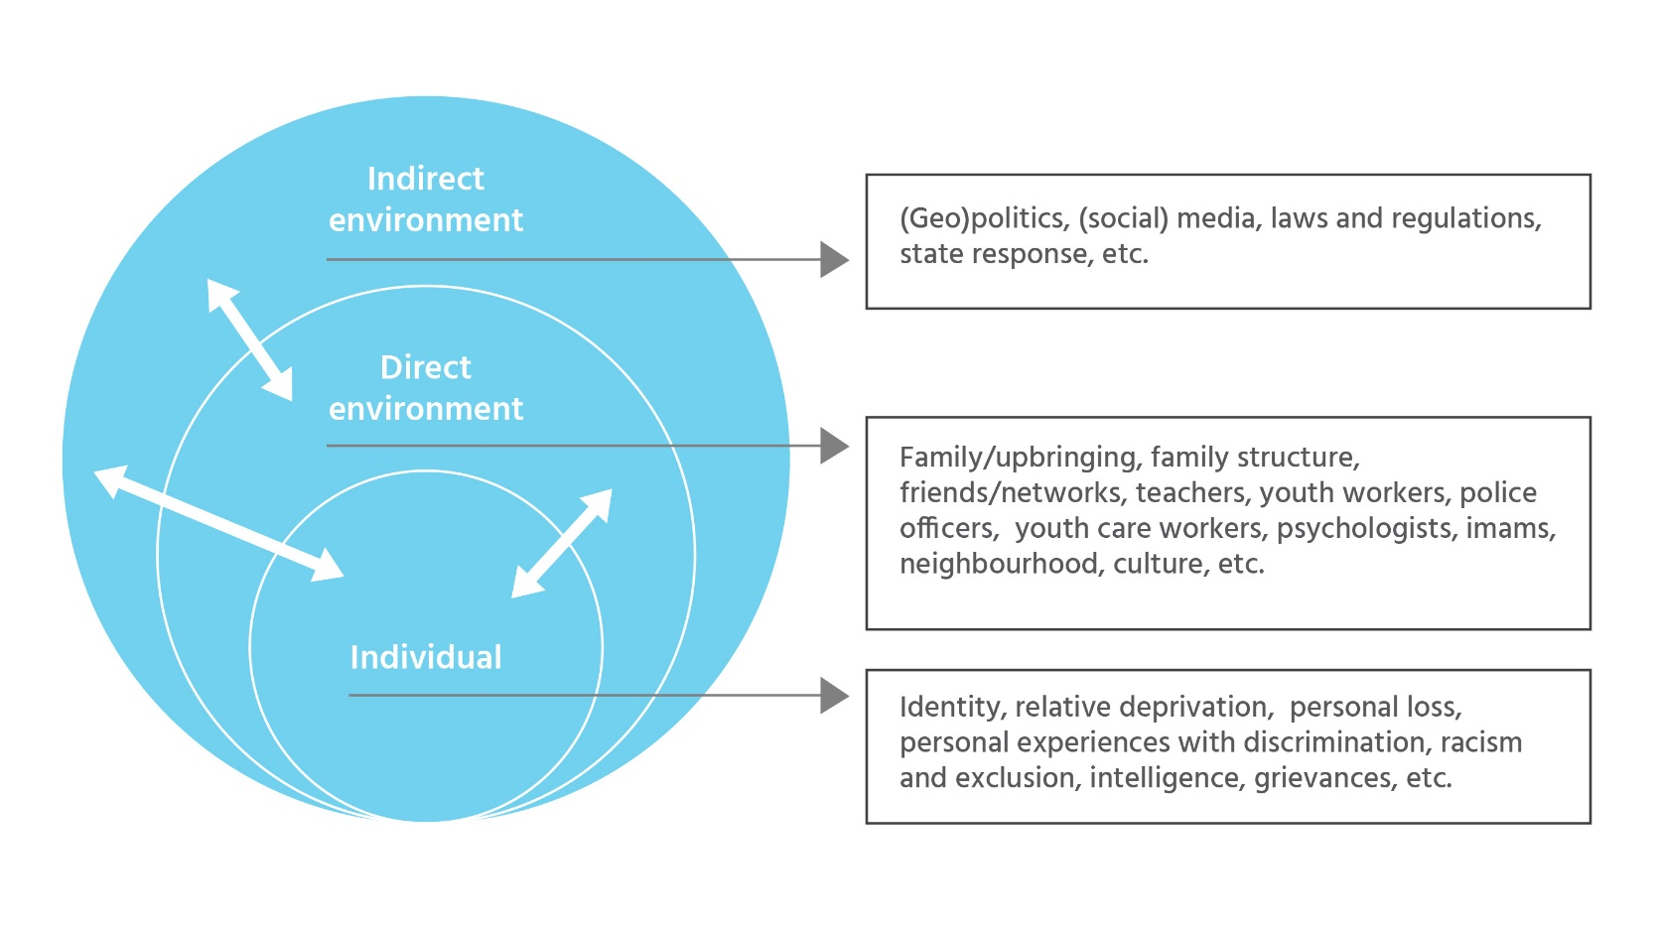
skills

