Train the Trainer Course, Day 1

Figure ‘Different levels of contributing factors to radicalisation’
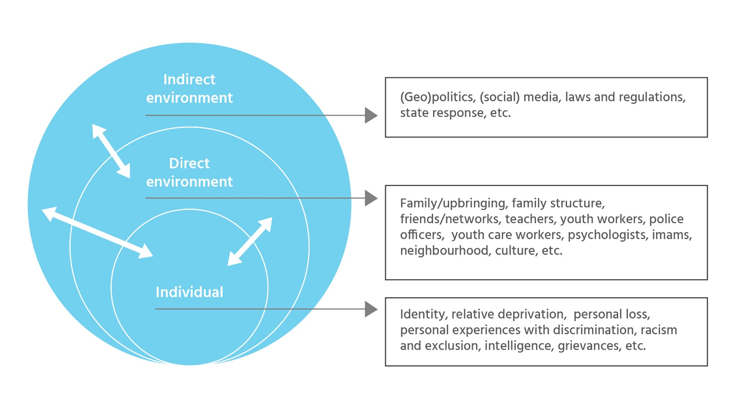
skills

