Train the Trainer Course, Day 2

Exercise “My Life Story”

Beginner, 10-12 yrs
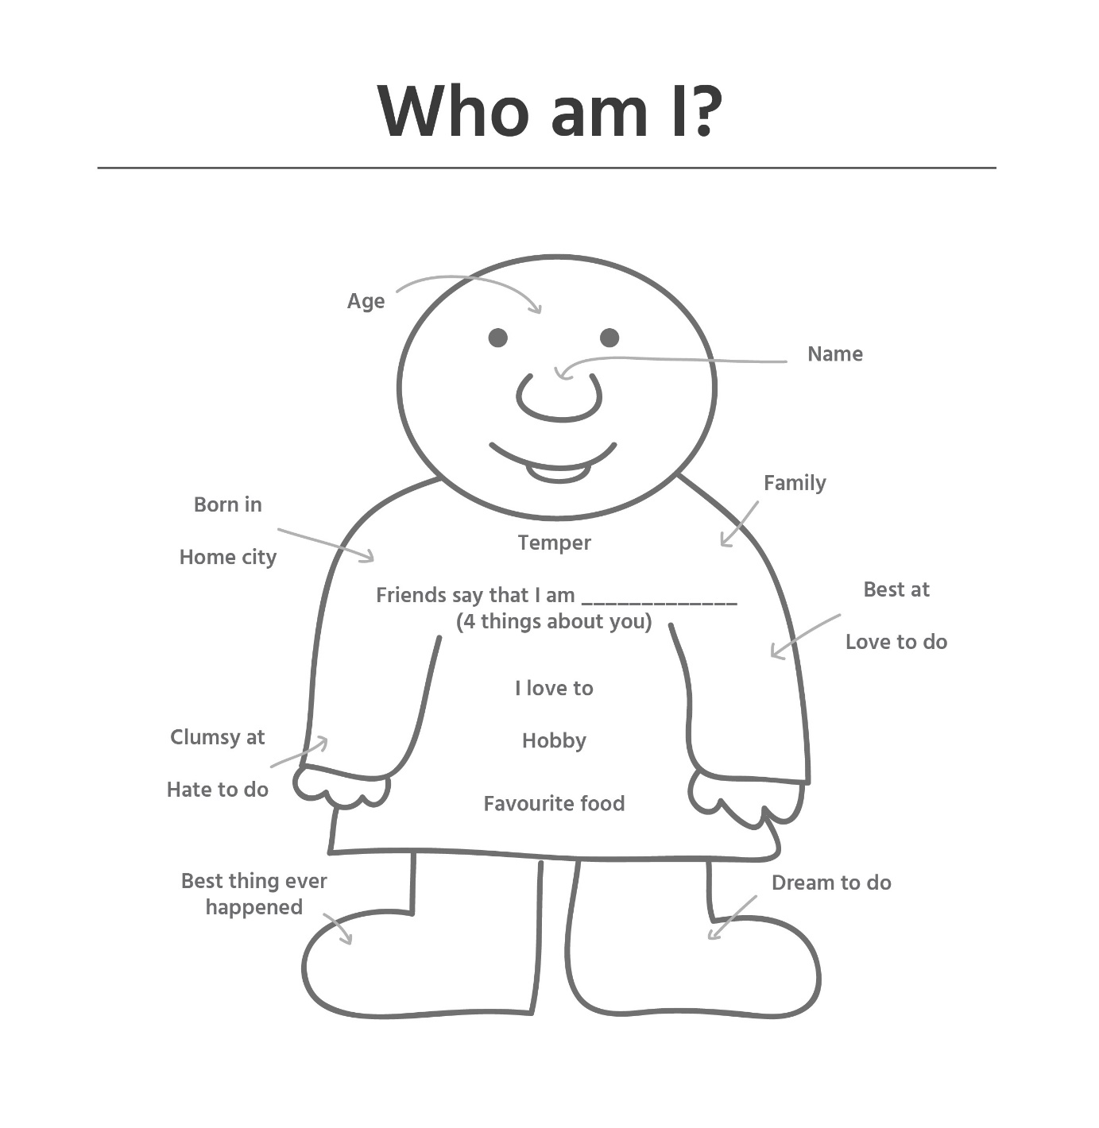

Intermediate, 12-16 yrs

Title of the book of your life
Chapter Titles  (significant events, stages in your life) | - ______________________________________________  - ______________________________________________  - ______________________________________________  - ______________________________________________  - ______________________________________________  - ______________________________________________  - ______________________________________________
Abstract:  One sentence summing up each chapter | - ______________________________________________  - ______________________________________________  - ______________________________________________  - ______________________________________________  - ______________________________________________  - ______________________________________________  - ______________________________________________
Final Chapter - The future: | What will you do in the future? Where will you go, and who will you be?  ______________________________________________________  ______________________________________________________
Oral presentation | Charm your audience  ______________________________________________________  ______________________________________________________

Advanced, 16-older
