Train the Trainer Course, Day 3

Exercise “Anything Goes”

Stage 1. Exercise: Are you good at active listening?
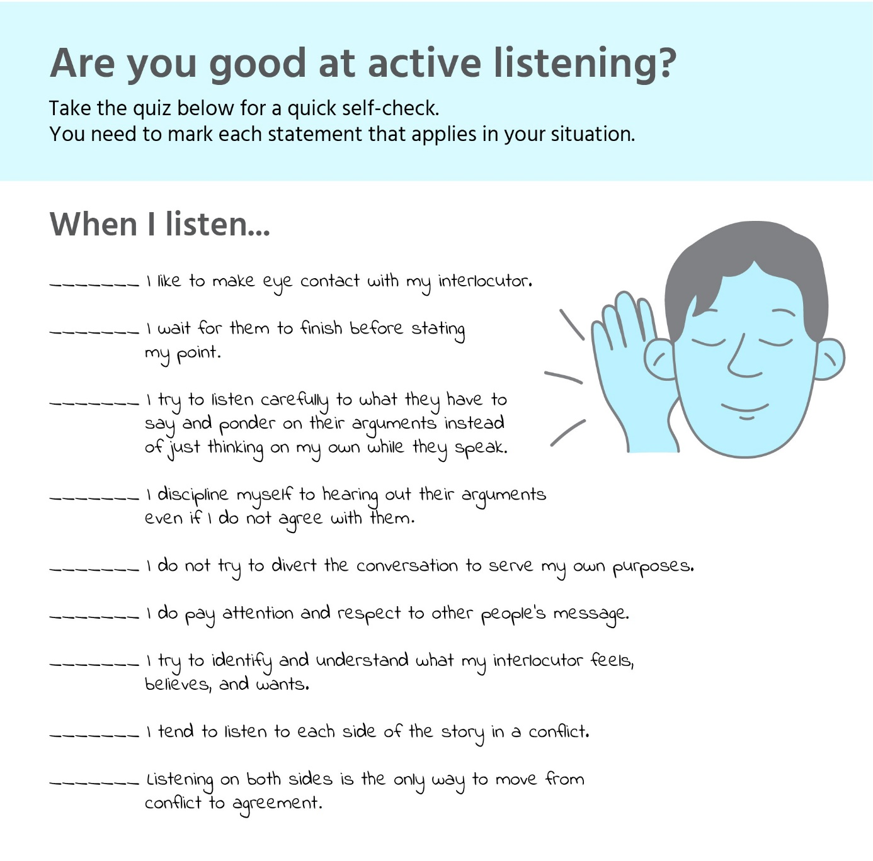

Stage 2. Exercise: Test your cognitive empathy
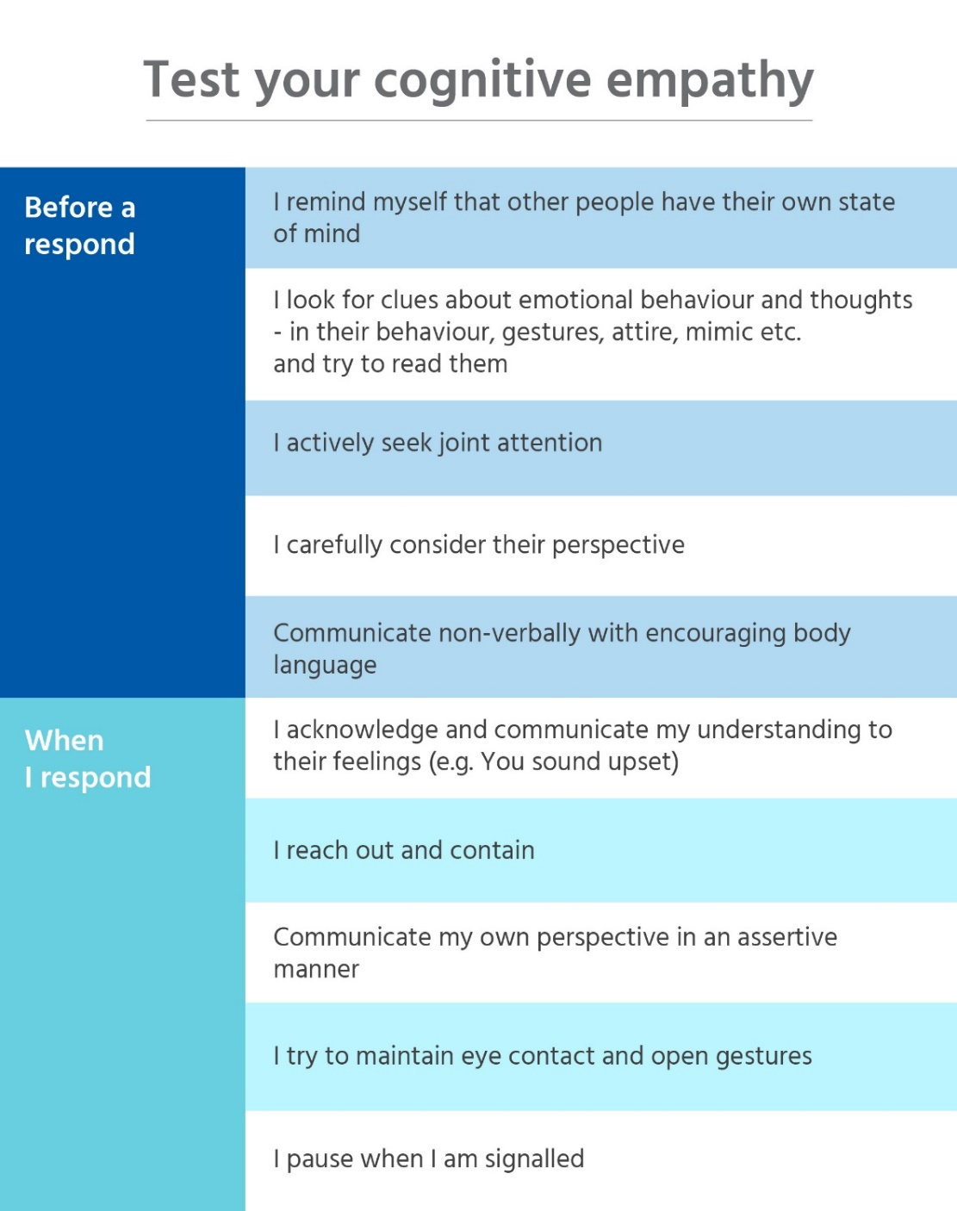
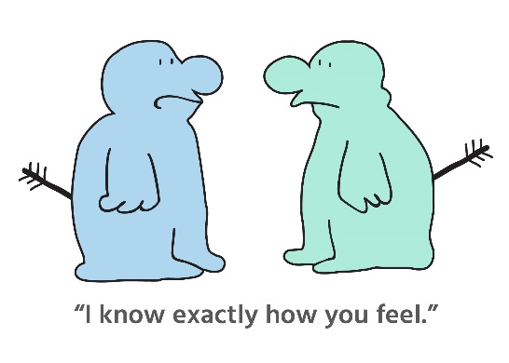
Stage 3. Wrap-up the discussion

- How did you react to your mini conflict?
………………………………………………………………………………………………………………………………………………
………………………………………………………………………………………………………………………………………………
………………………………………………………………………………………………………………………………………………

- Is this how you normally act in conflict situations? Why or why not?
………………………………………………………………………………………………………………………………………………
………………………………………………………………………………………………………………………………………………
………………………………………………………………………………………………………………………………………………

- How were you able to come to a consensus?
………………………………………………………………………………………………………………………………………………
………………………………………………………………………………………………………………………………………………
………………………………………………………………………………………………………………………………………………

- What happened when you switched from debate to dialogue?
………………………………………………………………………………………………………………………………………………
………………………………………………………………………………………………………………………………………………
………………………………………………………………………………………………………………………………………………

- When someone disagrees with you, do you always stop to ask questions?
………………………………………………………………………………………………………………………………………………
………………………………………………………………………………………………………………………………………………
………………………………………………………………………………………………………………………………………………

- Is it difficult to listen when someone disagrees with you? Why?
………………………………………………………………………………………………………………………………………………
………………………………………………………………………………………………………………………………………………
………………………………………………………………………………………………………………………………………………

- What made it easier in this activity?
………………………………………………………………………………………………………………………………………………
………………………………………………………………………………………………………………………………………………
………………………………………………………………………………………………………………………………………………

- In what ways could you use these skills the next time you’re in a conflict?
………………………………………………………………………………………………………………………………………………
………………………………………………………………………………………………………………………………………………
………………………………………………………………………………………………………………………………………………

